**HOMEWORK - VICTOR CATACORA ORTIZ**

|  |  |  |  |
| --- | --- | --- | --- |
| **1. Given the provided data, what are three conclusions we can draw about Kickstarter campaigns?** | | | |
|  |  |  |  |
|  | *The category theater register the more successful Kickstarter campaigns , followed by music and film video.* | | |
|  | On the other way, technology is the category with higher cancelled and failed percentage | | |
|  | For Journalism, all campaigns were canceled | | |

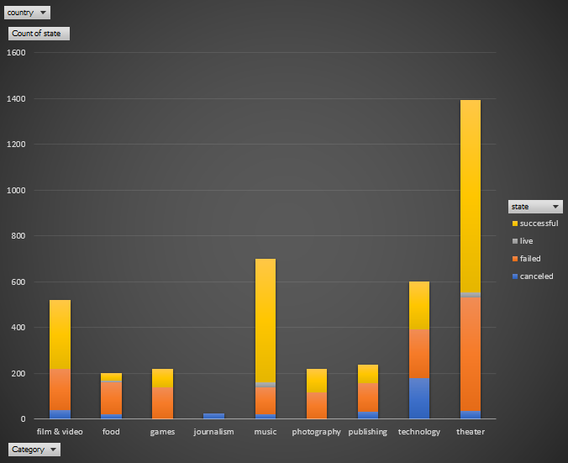

|  |
| --- |
| *Plays is the successful sub category top and web is thehighest cancelled sub category using Kickstarter* |
| *Rock is the subcategory with the hight success and with no canceled or failed using Kickstarter* |

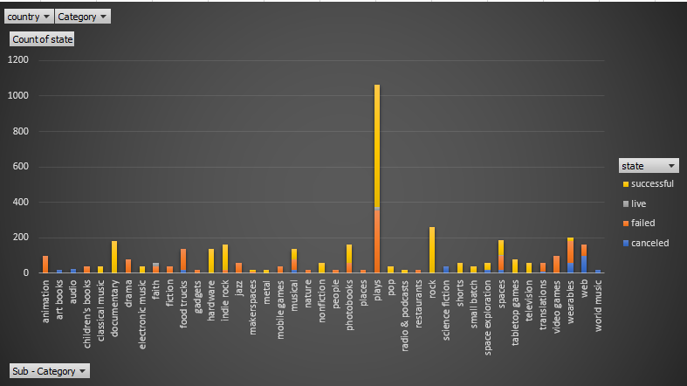

|  |
| --- |
| ***May is the successful Top Month using Kickstarter campaigns*** |
| ***July is the month when Kickstarter campaigns shows the highest failed events*** |

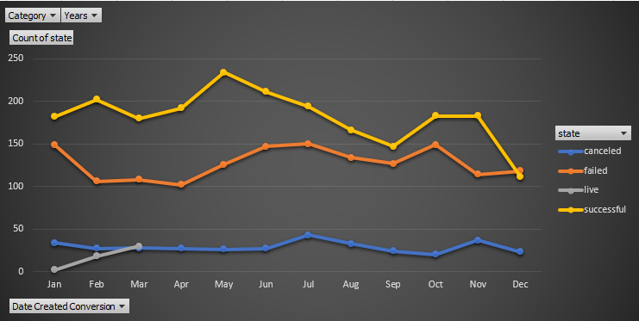

|  |  |  |  |  |
| --- | --- | --- | --- | --- |
| **2. What are some limitations of this dataset?** | | | | |
|  | ***Missing to include also the ages of the people to whom the campaign where directed***  ***Missing to include some other important and big countries.*** | | | | |
| **3. What are some other possible tables and/or graphs that we could create?** | | | |
|  | |  |  |
|  | | ***States vs Status*** | |

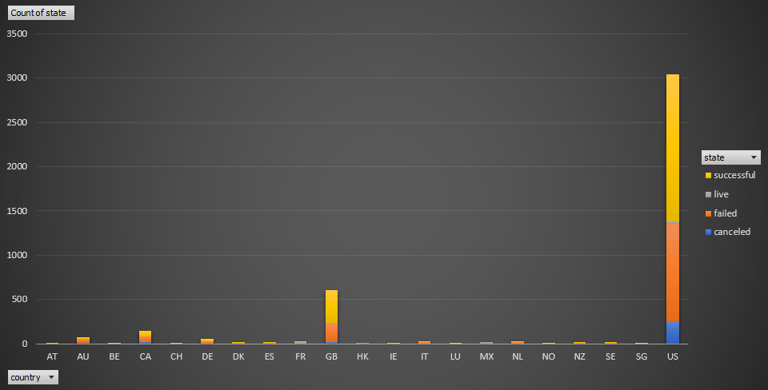

***Category vs Backer(Sum or Average) stacked by state***

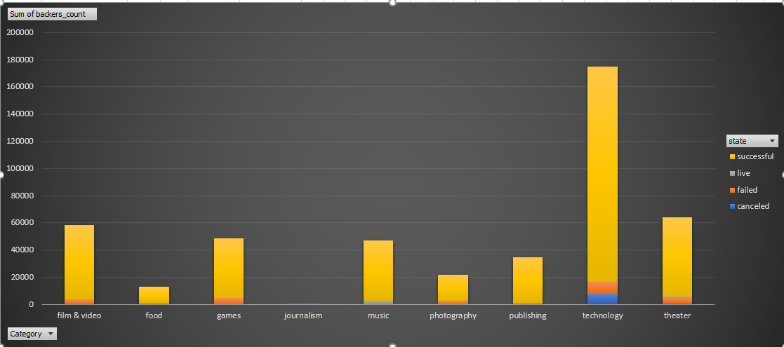

***SubCategory vs Backer(Sum or Average) stacked by state***

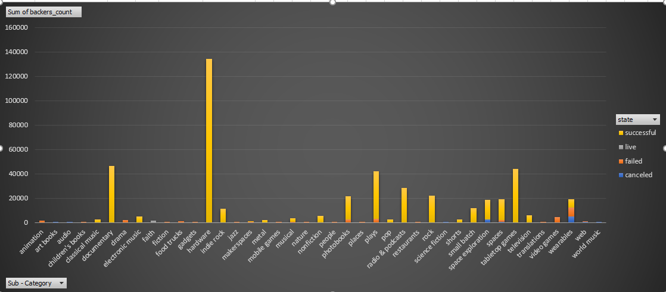

***SubCategory vs Pledge ( Sum or Average) stacked by state***

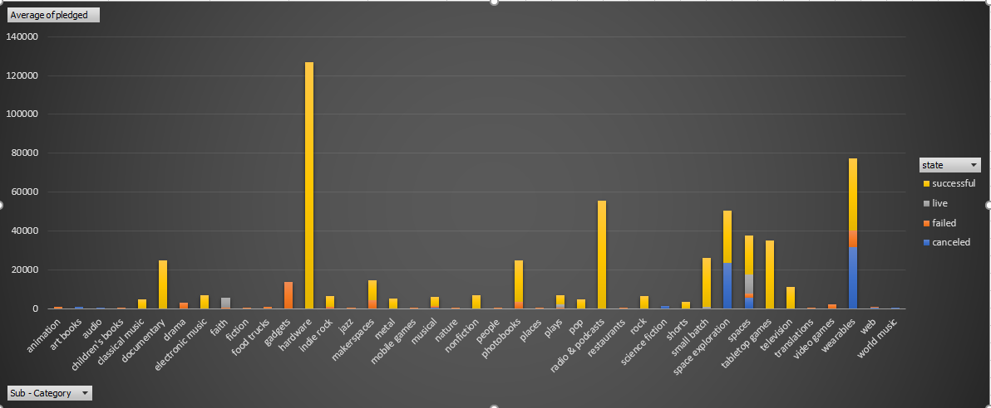

***SubCategory vs Goal ( Sum or Average) stacked by state***

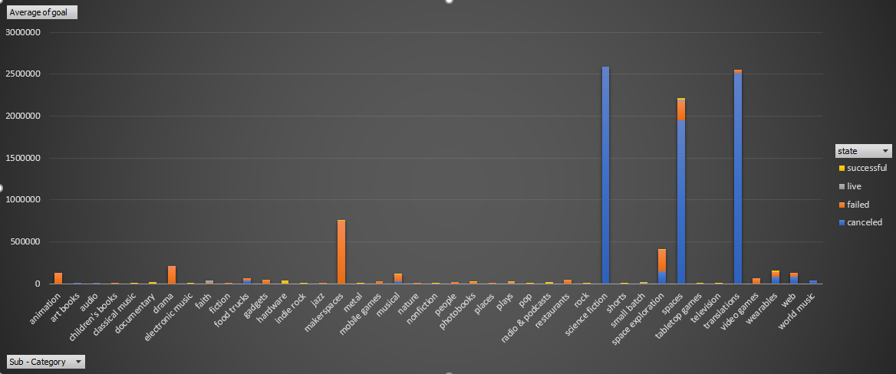

***Category vs Goal ( Sum or Average) stacked by state***

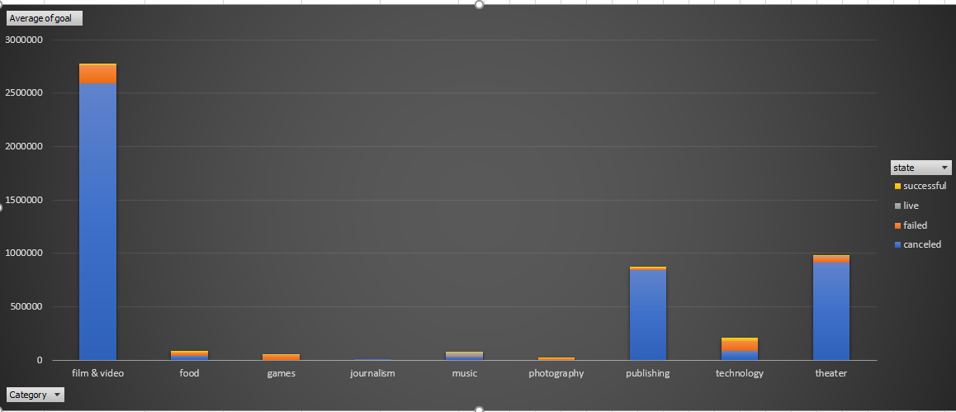

***Category vs Pledge ( Sum or Average) stacked by state***

